Welcome to 5th Grade Band Preview Night!
Ms. Roeser and Boyd Music are here to help you find your PERFECT instrument!
There will be three instrument stations to visit, and you can visit them in any order. Please select one of the instruments in each group to try! The instruments are organized this way to help each child and family try the instruments in an effective way. Also this method ensures that the instrument is aesthetically pleasing to the student!
Please circle the instruments you would like to try!
Pick One Instrument from the “High Sounds”
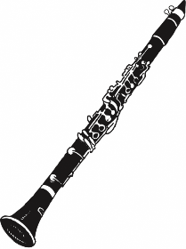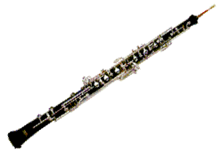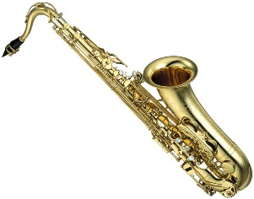
Flute Clarinet Oboe Alto saxophone
Pick One Instrument from the “Medium Sounds”
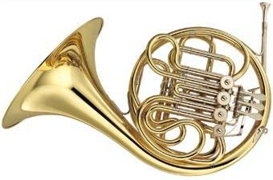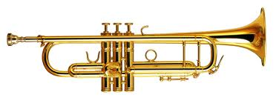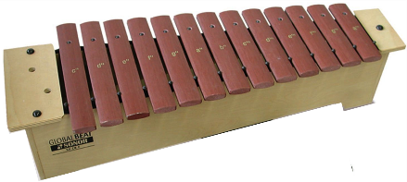
French horn Trumpet Mallet Percussion
Pick One Instrument from the “Low Sounds”
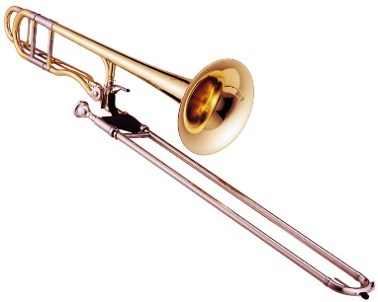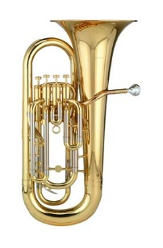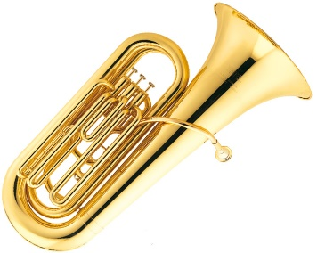
Trombone Euphonium Tuba

